Automatic Parish Donations with Flocknote

- St. John Parishioners go online using a computer or phone to: https://stjohnclyde.flocknote.com/give

St. Mary Parishioners go online using a computer or phone to: https://stmaryclifton.flocknote.com/give

- This screen will appear. Click: “Make a Gift”
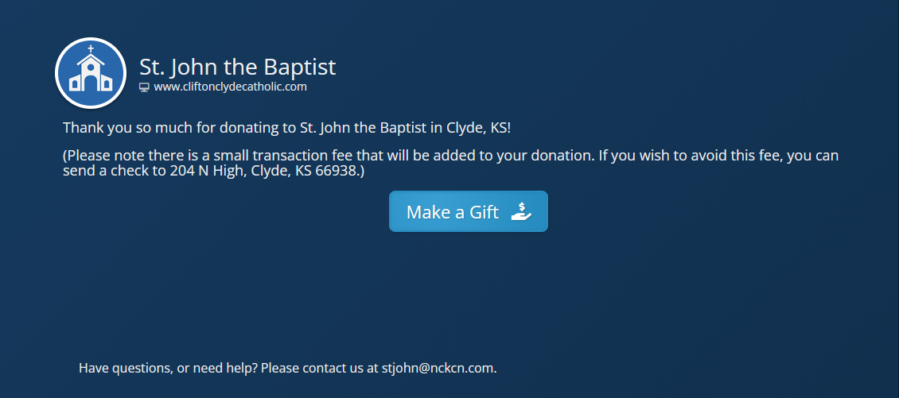

- Click: “DONATE”

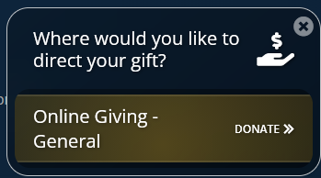

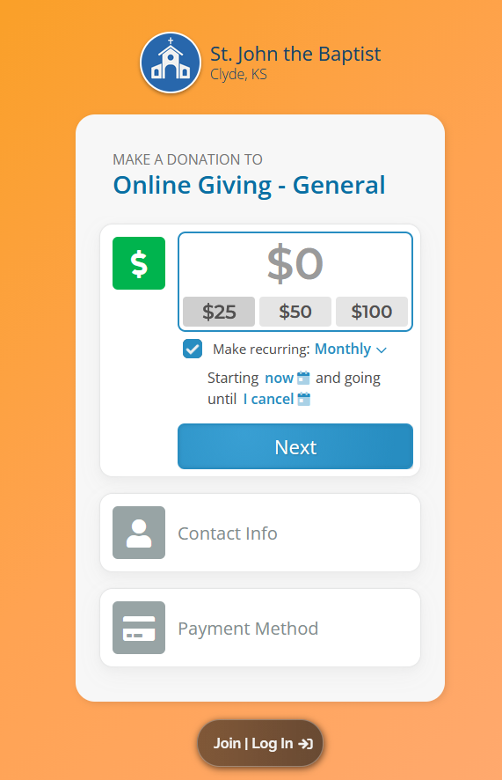
- Type the amount desired to donate.

-One time Payment: To make a one-time payment leave the “Make recurring” box unchecked.

-Recurring: To make recurring donations check the “Make recurring” box. Please choose weekly or monthly. If needed the amount can easily be changed or canceled in the future.

Note: If choosing monthly deposits multiply your current weekly amount by 4.333 to adjust for 52 weeks over the course of 12 months.

- Click “Next”.

- Type in your cell phone number and click “Next”.
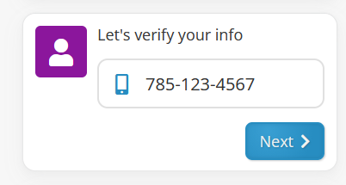

- Check the text messages on your phone. You will receive a new message containing a four-digit login code. Note: The login code is only valid for 5 minutes.
Type the code here:
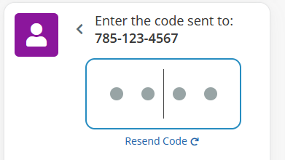
- Click how to pay and type in your bank or card information.

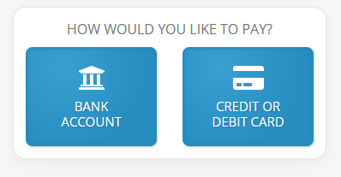

- After your payment is entered click “ Donate $--- Securely”
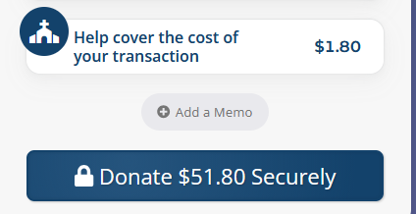

- The automatic donation is complete!
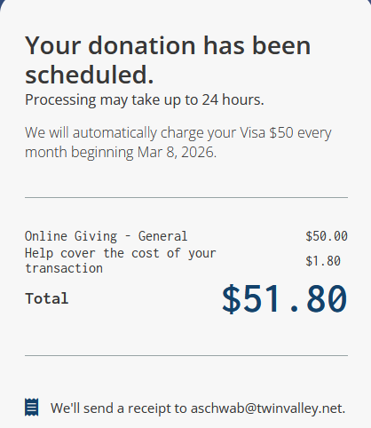

To change the amount, payment option or date of the reoccurring donations

